What is version control? You can find explanations in this chapter of the GitHub website: <https://git-scm.com/book/id/v2/Getting-Started-About-Version-Control>

It is important that you know how to use at least one Version Control System (VCS) given that it is common practice to work collaboratively on projects in many companies. In some cases, collaborative workers can be in different countries and operating according to different time zones so using VCS tools effectively is essential.

To encourage you to read the chapter on VCS and Git, answer the following:

* Why is Git more efficient at managing branch data (don’t worry about what branch data it yet) compared with say CVS?
* How are changes stored in Git?
* How does Git know about changes you make to files and directories - what does it use to determine this?
* What are the three main states that your files go through in Git?
* What does Git cloning do?

It is recommended that you learn the Git commands before choosing a GUI. This is because you can run all the Git commands from the command line but not from the GUIs.

You can run the commands from PowerShell in Windows or a Terminal window on a Mac or Linux system.

# Installing on RPi

To install Git on Linux it’s a simple case of using command: **apt-get install git** (as superuser). Check output to ensure it was successful.

# Configuring

To be able to push changes to a Git repository you need to specify your user name and email, as this data will be sent with your changes.

To do this use the following commands (expect no output from them):

$ git config --global user.name “Your name”

e.g. **git config –global user.name “leeagles”**

$ git config --global user.email “user@localMBP”

e.g. **git config –global user.email “leeagles@localhost”**

When testing, you might not want to use a real email. But, for more serious projects, you will want to add your email address.

You might also wish to setup your default text editor as the default Unix one is often used (not sure about Windows). The command to set the editor to emacs for editing Git message files, etc., is:

$ **git config --global core.editor nano**

To see what you have configured, use the following command:

$ **git config --list**

# Git commands – working with a cloned local repository

This chapter contains the basic commands (and explanations) to get you started. See: <https://git-scm.com/book/id/v2/Git-Basics-Getting-a-Git-Repository>

In summary, you will want to know how to obtain data from the repository which corresponds to your project, how to create a branch from which you will work from and how to apply your changes to the main project when ready. There are other commands you will need to know later, but for now, this is all you need to focus on.

Imagine your team has created a repository for your project – named RPi, each team member can clone it on their system and work on it at the same time.

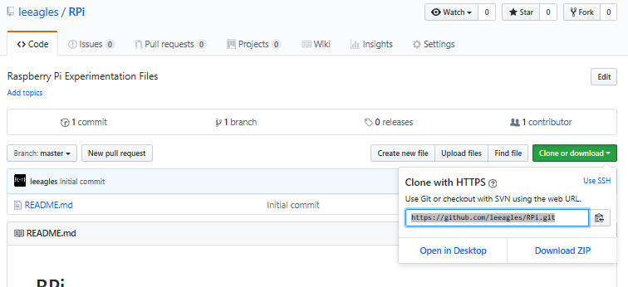

For your Devices and Prototyping files, first go to /var/www and then run the git clone command to **clone** your repository onto your RPi (see example below). That way, all files will be in the Web Area, ready for sensor data to be processed via PHP/MySQL, etc. The following shows you how I cloned my repository on my RPi (you can do this on as many systems as you wish).

$ **git clone https://github.com/leeagles/RPi.git**

This creates a directory named RPi and initialises a **.git** directory inside it. Do the same for your repository.

Use **ls -al** to see the files.

All the data from the repository is also pulled down, providing you with a working copy of the latest version. For more details, read this page: <https://git-scm.com/book/id/v2/Git-Basics-Getting-a-Git-Repository>

A useful command to use frequently is **git status**, which allows you to check what stage files are in, e.g. unmodified, modified, staged (changes to commit to project). When you first run the command, you will receive the message stating that there is nothing to commit.

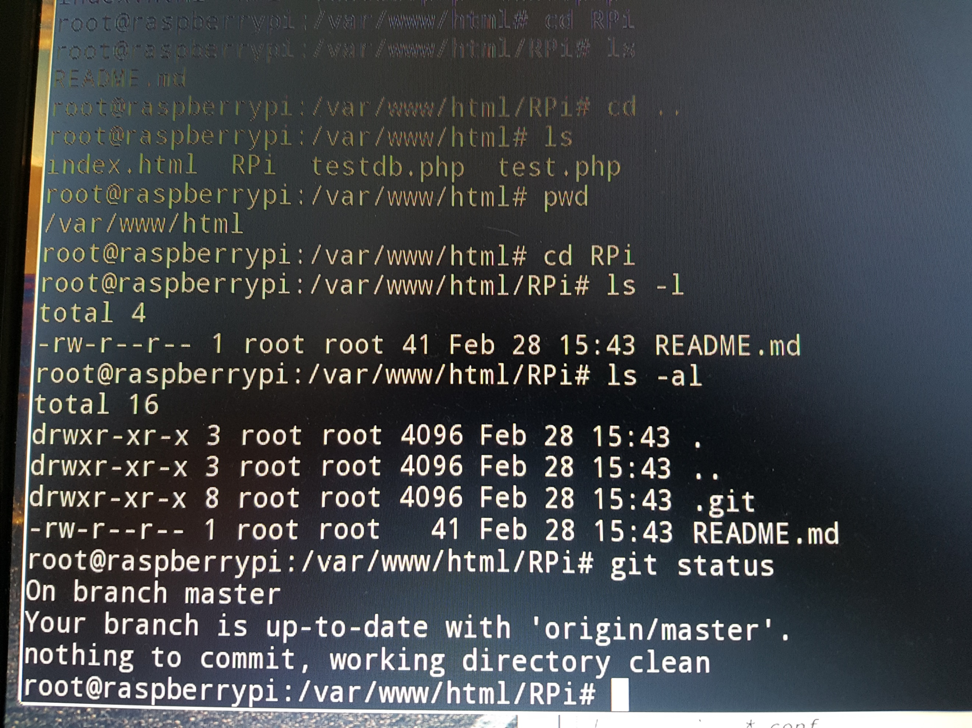

To include a new file in the project, create it on either GitHub or your Raspberry Pi. The following **shell_scripting_edited.docx** file was uploaded via a Browser and Committed:

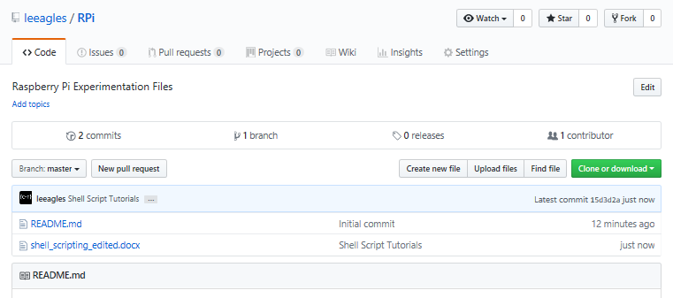

On the Raspberry Pi, run the **git pull** command, followed by **git status**. Run **ls -al** to see the file on your RPi.

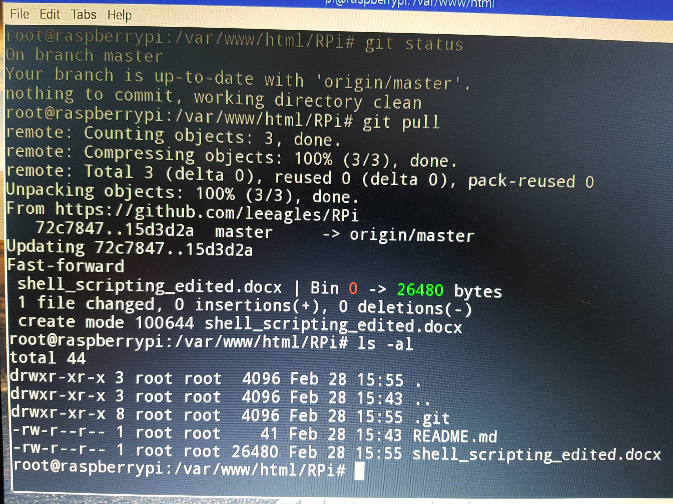

Running git status and ls -al will show that the branch (we’re just using master) is up to date.

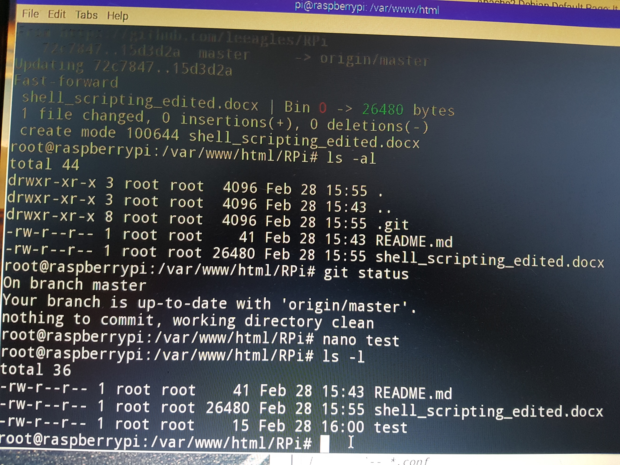

Adding a file via the Raspberry Pi:

Use **nano** to create a experimental file (it can be removed later).

Add the file to the repository using **git add** when you have changed it to make it part of the latest version.

$ **git add <file>**

You will see a message indicating the file is to be committed.

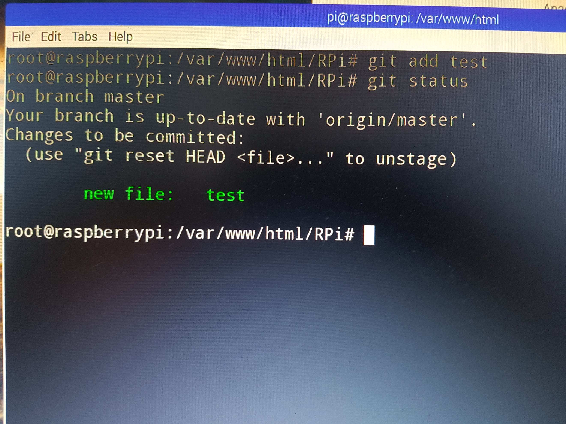

Note a conflict could occur when changes are pushed up to the repository if more than one person creates a file with the same name. This will not be in issue while it is local.

Run **git status**

To commit your changes, you use the git commit command. This will commit only staged data to your local project. Remember to add all files that you want to be committed.

$ **git commit –m “Adding test file”**

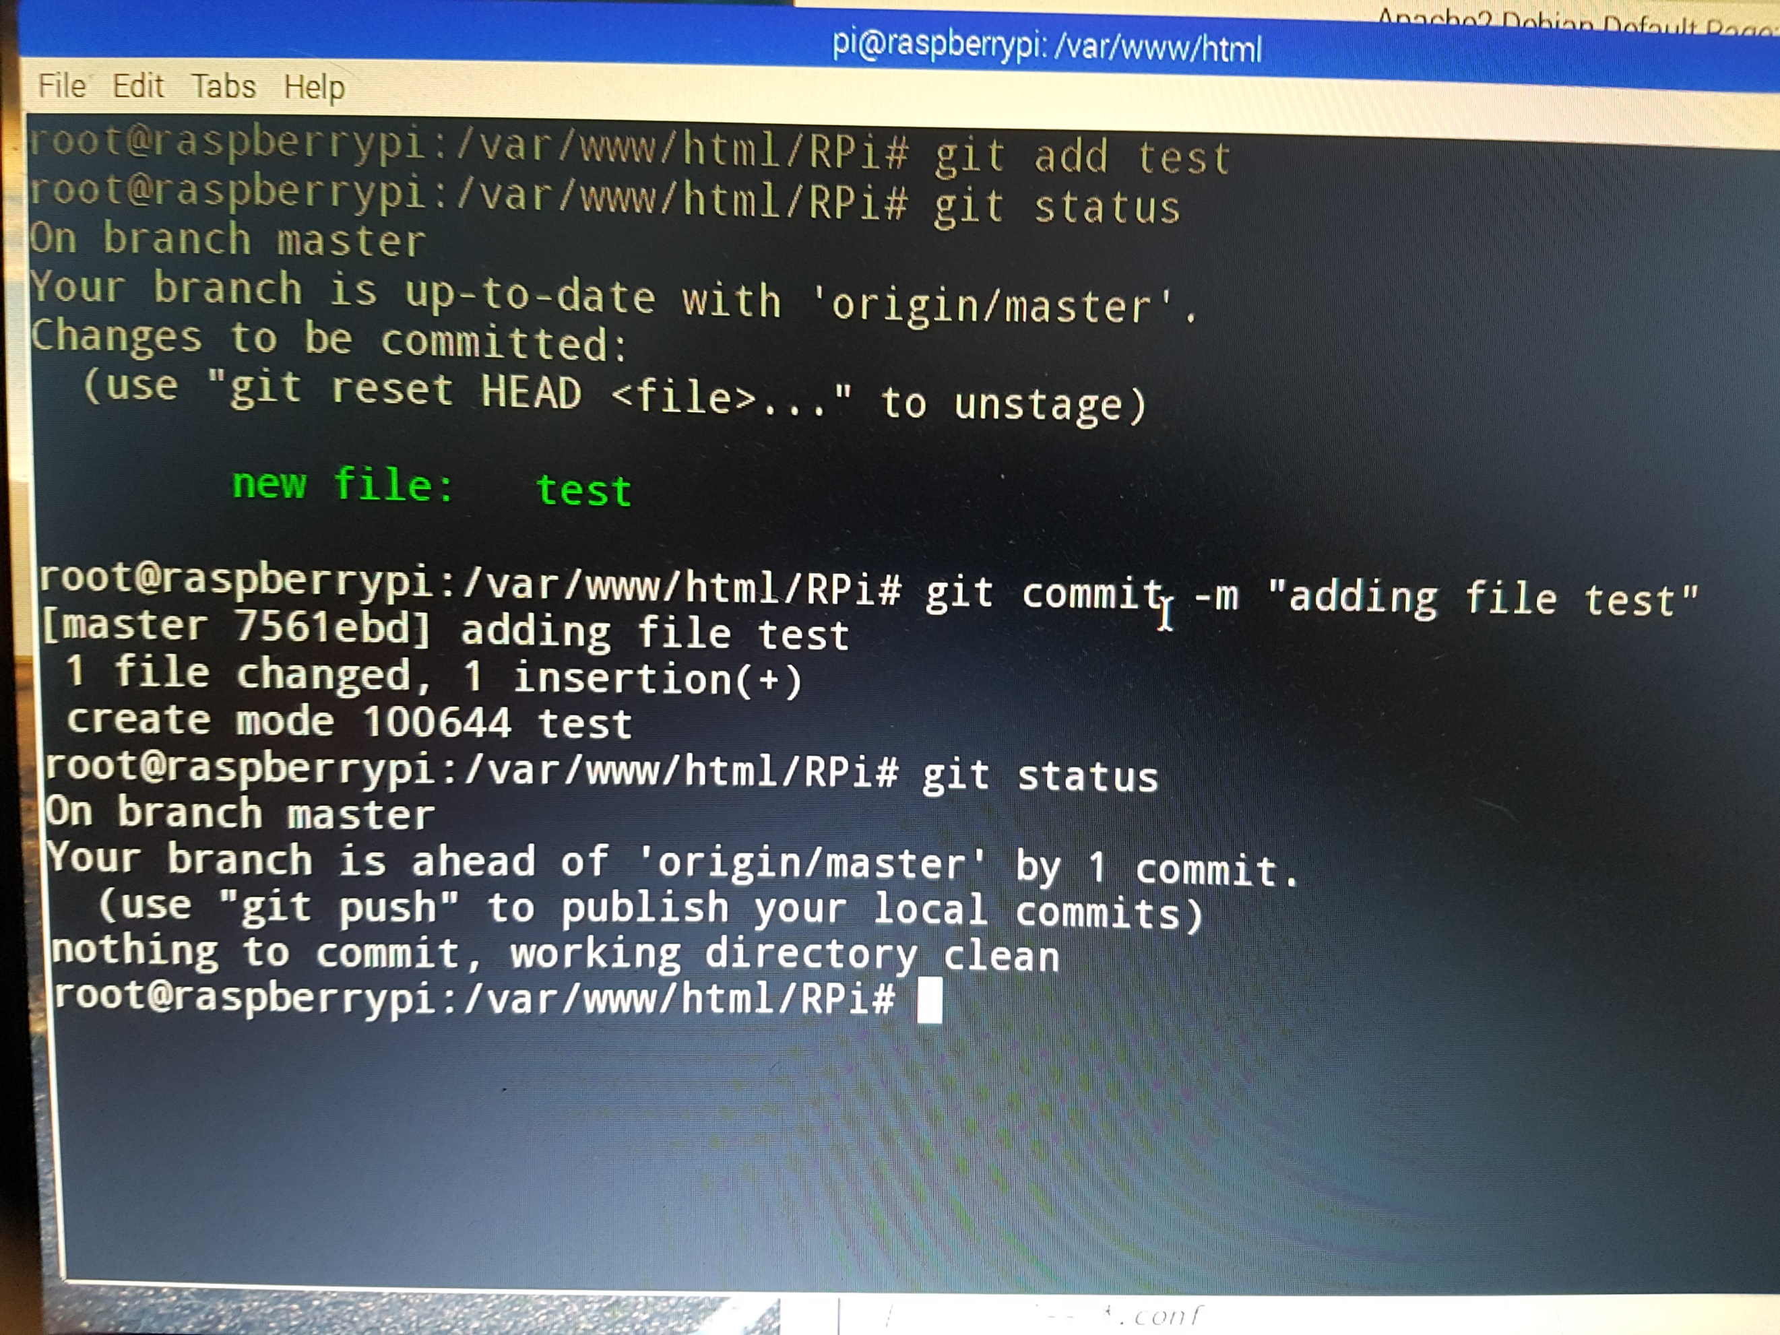

If you look on the Git Repository, you will not see the new file.

To get the file, you would run **git push** via the RPi.

For this you need to know the username and password to your remote Git repository.

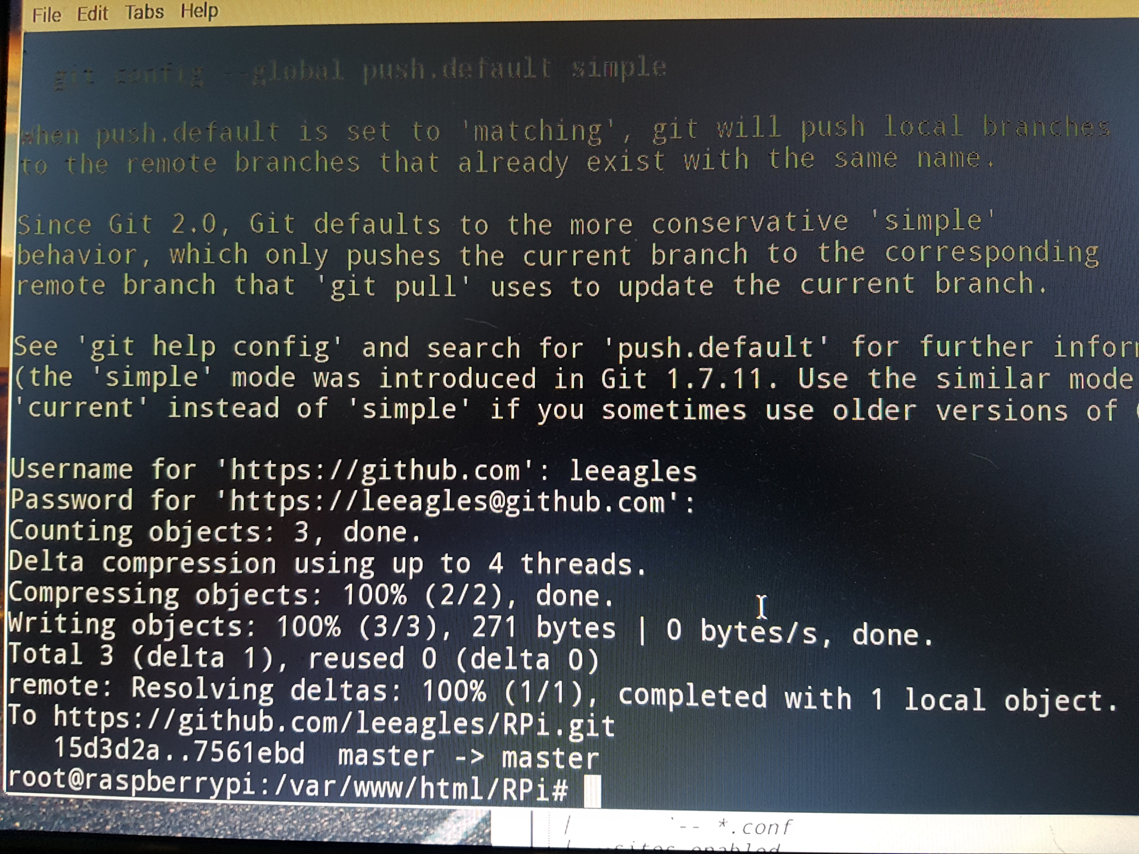

Now when you look at your remote Git repository, you will see the new file.

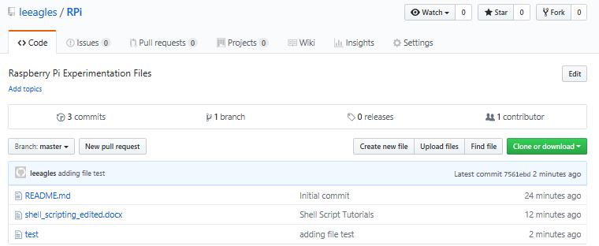

To view the commit history, use the git log command. This is useful when you are learning to use Git and you want to keep track or remember what you did, etc.

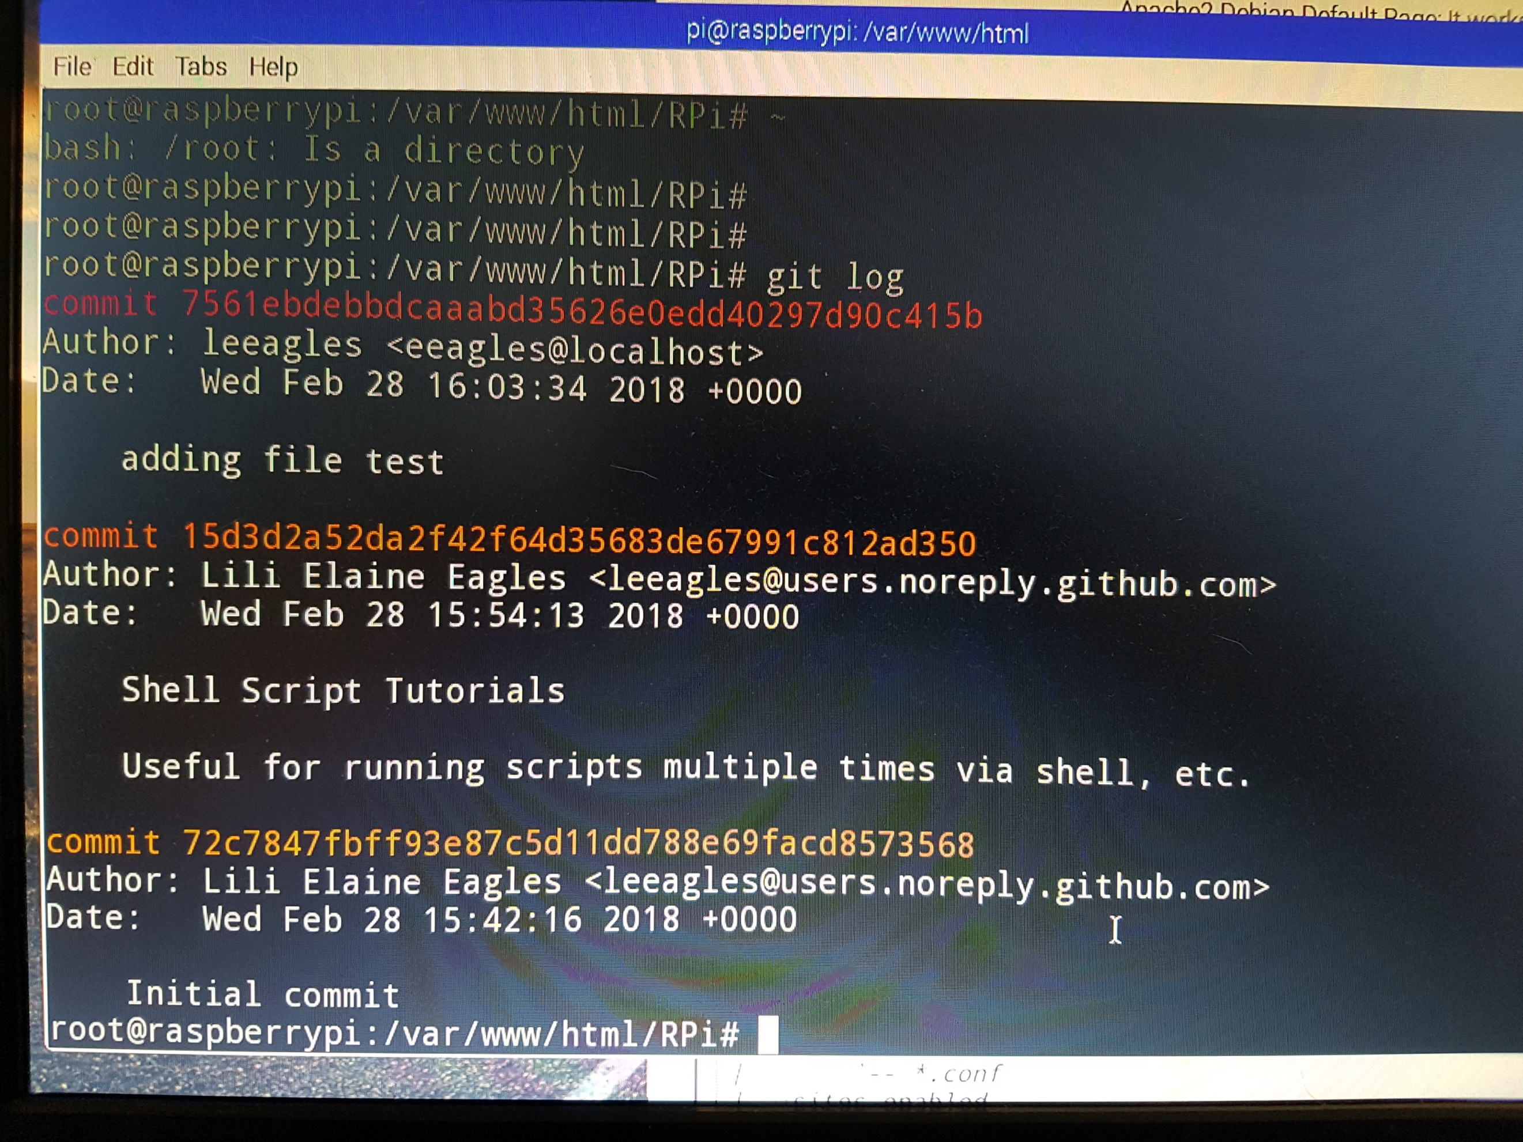

There is a way to ignore certain files too, which you can read about on the online tutorial. Another useful command is git diff, which shows you what you’ve changed but not yet staged.

The examples and screen captures you have seen so far have been based on the master branch. If I’d created a potential conflict, e.g. the master branch already had a file called test, I would need to merge the files.

Also, you have not worked with branches yet, which is how collaborative development is carried out - so now is the time to get to know about branching: <https://git-scm.com/book/id/v2/Git-Branching-Branches-in-a-Nutshell>.

**End of Part 1**